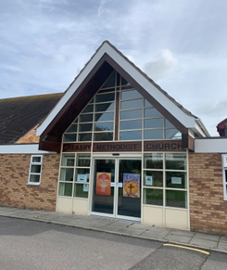
GREASBY
METHODIST
CHURCH

Greasby Road. CH49 2PN.
Minister: Rev. Yangsun Yi
Tel: Home 633 2753
Church Office Tel: 677 5127
Prayer Chain Contact: Mrs Joyce Scoffield
Email: joycescoffield@uwclub.net

Website: https://greasbymethodistchurch.org.uk

News-sheet – Sunday 2nd May. 2021.

Sunday 2nd May.
10.45am. Rev. Yangsun Yi (Communion Service)

WELCOME TO WORSHIP.
A warm welcome is extended in the name of Jesus to everyone. Visitors please feel free to make yourselves known and speak to a Steward. The Church has a loop system – please set your hearing aid as necessary.

Prayer.
Be light, O Lord, to our eyes, music to our ears and contentment to our heart. Be sunlight in our day, food at our table and rest to us in the night. Let us rejoice to be about your business and let us live to your praise and glory, now and for ever. Amen. John Cosin (1594-1672).

Sunday 9th May.
10.45am. Mrs. Judith Stelfox

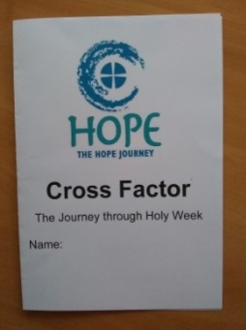
HOPE JOURNEY CROSS FACTOR

It was a joy to be able to share another Cross Factor with 29 Year 5 children and 2 staff at Brookdale Primary School last week, this time joining from home via Google Meet.
The morning had been postponed from before Easter and this time included -
- the Easter Story using a jig saw puzzle, which puts Jesus at the heart of the cross. We discussed the Last Supper on Maundy Thursday, The garden of Gethsemane, how Jesus was arrested and taken to the high priests house, before being taken to Pilate who ‘washed his hands of the affair’, Good Friday and Easter Sunday, following which the children designed a storyboard about what we were really celebrating at Easter
- A look at some crosses from around the world (Roman, Crucifix, Palm, Celtic, Salvadorian) and why we share Palm crosses on Palm Sunday. The children designed their own cross depicting scenes of the resurrection of Christ
- a Roman Soldier telling us his experience of being in Jerusalem during Holy Week and how he felt when being told to go and arrest Jesus – whom he believed to be a good man who had performed miracles and healed people. He thought Pontius Pilate would do the right thing and free Jesus - but he did not. And he was shocked and delighted to meet an angel at the tomb who said Jesus was alive. The children imagined being that Centurion and wrote a letter to a friend Maximus to tell him what had happened
- We thought about how some things can look dead – but are brought back to life – like a bulb before it grows into a beautiful flower and a chrysalis before it becomes a pretty butterfly. We believe that Jesus rose again and is alive and with us today and every day in our lives. We discussed what we may like to change in our own lives, in our community and in the world and the children wrote their thoughts on leaves which were glued onto a tree, demonstrating renewal of life

Again I have displayed some of work in the foyer, for your enjoyment

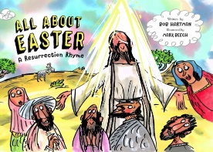
I gave the children 3 gifts from Greasby Methodist Church
- The Journey through Holy Week as a take home leaflet so that the children could colour the images whilst they shared the story with families
- All about Easter – a Resurrection Rhyme, published by the Bible Society this month. This included a special Easter blessing from us all at Greasby Methodist Church
- A Palm Cross – with an explanation of the significance of these crosses for Christians
I am now planning the next Hope Journey which is Explore for Year 3 children, which will take place in May. Whilst I remain grateful for the technology which has facilitated our Hope Journeys this year, I do look forward to when we are able to welcome the children into our church again for a more interactive learning programme.
Please join with me in prayer as we seek to continue our mission of sharing the good news with over 700 members of the Greasby community through our Hope Journeys this year

Sue Elliott, Hope Journey co-ordinator

OASIS WEDNESDAY 28th APRIL

At OASIS this week Rev. Derek Green shared with us, he talked of how his daughter had designed her garden and by helping her to create it he had felt closer to God who created all.
He then used an acrostic of the words WAKE UP in reverse to give his message.
He talked of his busy working life and when travelling had PAUSED to look at the countryside and looking closer led him to UNDERSTANDING and to EXPLORE the order of different KIND of things and how they interact.
He was AMAZED at the super mind that could have invented and then made all this.
He told of when waking we sometimes 'worry' about all sorts of things but instead of worrying we should start the day by WORSHIP of the creator God.

Next week Rev. Yangsun Yi will share with us on Wednesday at 12 noon, please telephone the Church office for meeting ID.

Sue Farrelly
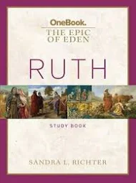
THURSDAY BIBLE STUDY
This week we started a new study on the book of Ruth led by Sandra Richter who is a Professor of Biblical studies in America. The course consists of some homework before we see a talk by Sandra via a video, which is then followed by a discussion. Sandra explains that the story of Ruth is about everyday lives lived with extraordinary integrity, Ruth being the outsider and Boaz the insider. We will be looking at the culture of the time and how their story plays its part in the coming of Jesus many years later (see Matthew chapter 1). I will let you know how we get on!

Judith Stelfox

CHURCH COUNCIL SECRETARY

Members will be aware that the responsibilities of the Church Council are laid out in Constitutional Practice and Discipline of the Methodist Church (CPD)
Responsibilities. The general oversight of the Local Church shall be undertaken by the Church Council, exercising leadership over the whole field of the church’s concern. Standing Order 614

The Church Council therefore has authority and oversight of the whole ministry of our church, including the management of its property.

We are seeking to appoint a Church Council Secretary at the earliest opportunity

The role involves working with the minister to agree and publish the agenda for the Church Council meeting(s) which currently meets three times a year, together with the publication of minutes for approval at the following meeting. The postholder would also provide the admin support to enable the General Church Meeting to take place. This is usually held April of each year, however it has been postponed until 8th July. There will occasionally be some additional duties such as sending greetings from the Church Council or electronic communication to Church Council members. It is a critical role in the life of the church, without which Church Council will not be able to meet in order to fulfil its responsibilities. We ask you to prayerfully consider whether God is calling you to serve in this capacity. Please do speak to me for further details or any of the stewards if you feel able to offer this vital role
Sue Elliott
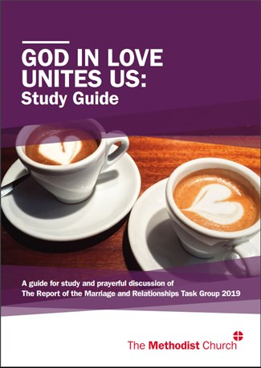

GOD IN LOVE UNITES US

Steve Cooper (Circuit Manager Wirral Methodist Circuit) has kindly shared the following on behalf of Rev Heather Cooper, Circuit Superintendent

The District Synod met by Zoom on Saturday 24th April to consider the resolutions that had been referred by the Conference for consultation.

The full text of the resolutions can be found in the full conference report (https://www.methodist.org.uk/MandR19/) but in summary, subject to Conference 2021 confirming them, they would:
10/2 – agree principles of good human relating
10/3 – recognise the presence of God in healthy cohabitation relationships
10/7 – update the Guidance on Marriage
10/8 – permit, where desired, the marriage of Same-Sex couples on Methodist premises (with safeguards to ensure that no minister or other authorised person is required to conduct any marriage contrary their conscience).
10/9 – amend the standing orders to put these changes into effect.

Each of the resolutions were discussed and voted upon in turn, the debates were conducted in a gracious atmosphere with speakers both in support and against these proposals and in each case the voting was substantially in favour of the resolutions being passed. The following figures relate to members “present and voting” – abstentions do not form part of the process – there were between 81 and 83 voting members in attendance and the participation in the voting was between 75 and 81 across the votes.
10/2 – 91% in favour, 9% against
10/3 – 85% in favour, 15% against
10/7 – 84% in favour, 16% against
10/8 – 81% in favour, 19% against
10/9 – 83% in favour, 17% against

These figures, together with significant comments, have been reported to the Conference Office who are consolidating the reports from each of the synods across the connexion, and other submissions, for a report to be brought to the Conference in late June. Although figures have not been officially shared, the soundings from Facebook seem to suggest that almost all of the Synods have similarly passed the resolutions with substantial majorities.

Please continue to pray for the God’s wisdom and grace for the members of Conference who will be making the decisions on confirming these resolutions, or not, in late June.
Sue Elliott

PRAYER NEEDS 2nd May
The Lord is my shepherd, I lack nothing. He makes me lie down in green pastures, he leads me beside quiet waters, he refreshes my soul. (Psalm39)

People:

Please pray for the country of India, and all its people struggling to survive the devastating consequences of the Corona Virus. To see the pictures each night on the news, is just heartbreaking, to see people dying in the streets, and in cars, as the hospitals try in vain to cope with the ever increasing numbers. Oxygen is running out, staff are exhausted, amid India’s crumbling infrastructure.

We pray Lord, that International aid will arrive in time to help some of the people, that oxygen cylinders will be delivered to the hospitals in most need, and that soon the virus will hopefully respond to the vaccine programme, but sadly that is far away at this present time.

For all of our church family who are waiting for tests or appointments at hospitals, may they know God’s comfort at a worrying time.

On this rather different Bank Holiday weekend, we hope that families can enjoy their time together again, and can travel further safely.

We pray that more of our churches in the Wirral circuit which are planning and hoping to re-open their doors after May 17th, will be able to do so with confidence and congregations can be welcomed back in safety. Won’t it be wonderful to be able to SING again!!

We give thanks for the vaccines reaching the 40’s age group in these coming weeks, and for the very welcome news that at last we can see a drop in deaths and hospital admissions, but we are not virus free yet, and must remain careful.

Lord Jesus may your light
Continue to shine in the darkness
Keep us for ever in your strong grasp
And may the darkness that is all around us
And within us
Never to be able to extinguish
Your heavenly light. Amen.

Church Notices –If you have any notices that you would like to go in the weekly news-sheet please telephone Caroline in the Church office or email office@greasbymethodistchurch.org.uk by Thursday morning. Thank you.Privacy notice

We have a TMCP (Trustees for Methodist Church Purposes) compliant privacy notice available on our website greasbymethodistchurch.org.uk
A paper copy is available on the notice board and can be provided upon request from any steward.

