GREASBY
METHODIST
CHURCH

Greasby Road. CH49 2PN.
Minister: Rev. Yangsun Yi
Tel: Home 633 2753
Church Office Tel: 677 5127
Prayer Chain Contact: Mrs Joyce Scoffield
Email: joycescoffield@uwclub.net
Website: https://greasbymethodistchurch.org.uk

News-sheet - Sunday 4th April. 2021.
Easter Day.

Sunday 4th April.
10.45am. Rev. Charles New. (Church Service including Holly Communion).

WELCOME TO WORSHIP.
A warm welcome is extended in the name of Jesus to everyone. Visitors please feel free to make yourselves known and speak to a Steward. The Church has a loop system – please set your hearing aid as necessary.

Prayer.
The blessing of the night, O Lord, you have given us for rest and the gift of the day to praise your glory. Keep us each day from all sin, protect us in the hour of temptation and guide us with the light of your presence; through Jesus Christ our Lord. Amen. John Calvin (1509-1564).

Sunday 11th April.
10.45am. Rev. Yangsun Yi.

EASTER OFFERING ‘INTO ALL THE WORLD’

Each year, the Methodist Church holds an Easter Offering dedication service. This tradition dates back to 1883, when women in Manchester collected £32 for missionary work overseas from 'Christmas pennies' at family gatherings on Christmas Day. In March 1884, the London Districts distributed Easter envelopes and collecting bags asking for a penny a head, and collected around £100. In 1900, Women’s Work raised £1,655 for the work of overseas missions.

Since then, each successive Methodist women’s movement has encouraged donations in support of God’s mission. Recently, Methodist Women in Britain (supported by the Global Relationships Team GRT) have produced an annual service of dedication, often used widely around the Connexion as a circuit service.
All the money raised through the Easter Offering goes to the World Mission Fund of the Methodist Church in Britain for work in 65 Partner Churches around the world. This money is used by overseas partners to fund such work as: enabling young women in north India to undertake nurse and midwifery training; supporting Brazilian women to work in their churches with vulnerable women and children; developing women’s leadership roles and integrating culture and art into worship across Brazil. In 2019, collections from Easter Offering services raised over £370,000, thanks to the generosity of Methodist men, women and children.

This year the 2021 Easter Offering theme ‘Into all the World’ has been carried over from last years cancelled event in a service that features people who have made a journey, some in obedience to God’s call on their lives, and others because they had no choice. The worship encourages us to reflect and learn from those who travel and to consider our own journeys – both physical and spiritual. It has been made available this week on a new MWiB YouTube channel (search MWiB) and I have copies of the service sheet for anyone who would like a copy. The service is just 38 minutes long and also aims to raise awareness of how Covid-19 has affected some of our World Church Partners, to discover how grants of £500,000 from the World Mission Fund have been helping people in our partner churches, to learn how we can pray for our sisters and brothers affected by this virus, and to encourage giving to the World Mission Fund which did not receive the usual generous donations in 2020
Envelopes and bookmarks are available on seats. Donations can be left in the sealed envelope (together with Gift Aid declaration where appropriate) in the plate at the exit today or in the next two weeks. With grateful thanks for your very generous support over many years

Sue Elliott On behalf of MWiB

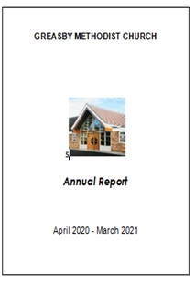
GENERAL CHURCH MEETING

The General Church Meeting planned for Sunday 11th April has been postponed to 7.30pm Thursday 8th July, to coincide with a meeting of Church Council, when everyone is welcome to attend
I do want to thank all those who forwarded reports for the Annual Report. I have emailed a copy to all for whom we have an email address and the report is also available on the website. However print copies are also available for collection in the atrium - please advise if you would like a print copy delivering to your home (phone 632 2672 and leave a voicemail). Please do take time to read the report and praise God for the many blessings we have received throughout what has been a challenging year, and pray for wisdom and guidance as we develop our Mission Plan for 2021-23

May the God of hope fill you with all joy and peace as you trust in him, so that you may overflow with hope by the power of the Holy Spirit Romans 5v13 (NIV)
Sue Elliott

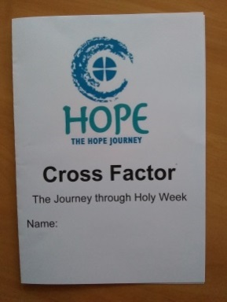
HOPE JOURNEY CROSS FACTOR
What a joy to be able to share Cross Factor with 64 Year 5 children and 4 staff at Greasby Junior School on Monday afternoon this week. Unfortunately the Circuit Children and Youth team were unable to support but I was able to make contact from home using Google Meet and utilise some Hope Journey materials
Last week the Ecumenical Assemblies Team prepared a videoed assembly entitled ‘Easter in a Nutshell’, which highlighted the death and the resurrection of our Lord Jesus Christ. To compliment the assembly

- I talked through the Easter Story using a jig saw puzzle, which puts Jesus at the heart of the cross. We discussed the Last Supper on Maundy Thursday, the garden of Gethsemane, how Jesus was arrested and taken to the high priests house before being taken to Pilate who ‘washed his hands of the affair’, Good Friday and Easter Sunday, following which some children designed a storyboard about what we are really celebrating at Easter
- We looked at some crosses from around the world (Roman, Crucifix, Palm, Celtic, Salvadorian) and why we share Palm crosses on Palm Sunday. Some children designed their own cross depicting scenes of the resurrection of Christ

I have displayed samples of their work in the foyer, for your enjoyment
We were able to share 3 gifts from Greasby Methodist Church
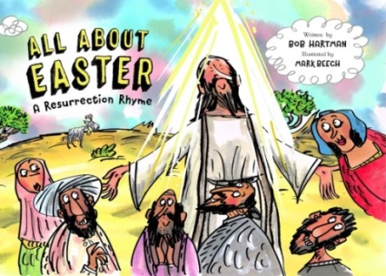
- The Journey through Holy Week as a take home leaflet (see above) so that the children could colour the images whilst they shared the story with families
- All about Easter – a Resurrection Rhyme, published by the Bible Society this month. This included a special Easter blessing from us all at Greasby Methodist Church

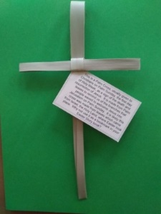
- A Palm Cross – with an explanation of the significance of these crosses for Christians

The next Cross Factor for Year 5 children at Brookdale Primary will take place on Wednesday 14th April.

I am now planning the next Hope Journey which is Explore for Year 3 children, which will take place in May. Whilst I remain grateful for the technology which has facilitated all our Hope Journeys this year, I do look forward to when we are able to welcome the children into our church again for more interactive learning. It is a great privilege that the schools are so willing to engage with us and that we continue to contribute to children’s learning and the RE curriculum.

Please join with me in prayer as we seek to continue our mission of sharing the good news with over 700 members of the Greasby community through our Hope Journeys this year
Sue Elliott
Hope Journey co-ordinator

OASIS WEDNESDAY 31st MARCH

This week at OASIS we were very pleased to welcome Yangsun's friend and colleague, Thuama, who joined us via Zoom from Myanmar. Thuama's powerful and moving talk was titled 'Myanmar - The Curse of Security. Thuama began by reading John 10:10 where Jesus says 'The thief comes only to steal and kill and destroy. I have come that they may have life and have it to the full.'

Thuama told us of the history of Myanmar, the former Burma. He told us that it is a multi-cultural, ethnic and religious society and that it has the largest army in the world. The army priorities security and controls all aspects of life and justifies its actions in the name of National Security. He spoke of how Jesus challenged the security of the military on the cross by making himself vulnerable to death. Thuama ended by asking for our prayers for his country Myanmar.

Next week Mrs. Judith Stelfox will be sharing with us, when we will me at the new time of 10.30-11.00am. If you would like to join these online Zoom meetings please contact the church office on 677 5127 or Paul Boardman on 07846713810
Sue Farrelly

DISCIPLESHIP AND FELLOWSHIP DAY
SATURDAY 11th SEPTEMBER

Please be advised that the Discipleship Day due to be held on 24th April has been postponed to Saturday 11th September, 10.00 - 3.30pm when Mark Thomas will be leading on the theme Defending the Faith.

Always be ready to give an answer
1 Peter 3 v13-17

The aim of the day is to introduce disciples of Jesus to the study of Apologetics. B the end of the day we will be able to give a reasoned argument for the existence of God, the divine nature of Jesus Christ and the authenticity and authority of the Bible. It promises to be an exciting day of learning through discussion, reflection and fellowship with one another and will include refreshments and a light lunch. Please keep the date free and plan to join us if you are able
Sue Elliott

READINGS 4th April. 2021
 |  | Reading | Hymn | Psalm
Sunday | 4th | Song of Sol 8:5b-7 | StF282 | Ps121
Monday | 5th | Mathew 27:11-54 | StF277 | Ps31-9-16
Tuesday | 6th | Isaiah 42:1-9 | StF338 | Ps36:9-16
Wednesday | 7th | Isaiah 49:1-7 | StF17 | Ps71:10-14
Thursday | 8th | Isaiah 49:1-7 | StF319 | Ps70
Friday | 9th | 1 Corin 11:23-26 | StF572 | Ps116
Saturday | 10th | Isaiah 52:13-53-12 | StF285 | Ps22

PRAYER NEEDS 4th April 2021
Meanwhile Jesus stood before the governor, and the governor asked him, “Are you the king of the Jews?” “You have said so,” Jesus replied.
(Mathew 27:11)
PEOPLE :

We offer so many thanks to you Lord, that today on Easter Sunday we are finally able to open our church, and worship you. Alleluia, He is Risen, He is Risen indeed.

The speaker at this week’s Oasis was a friend of Yangsun’s. His name was Thuama, and he lives in Kala-ywa, in Myanmar. Thuama said he believed that God is with the suffering people, and that very soon He will graciously grant the people of Myanmar peace and prosperity.
We at Greasby, wholeheartedly echo his prayer for the terrible events and suffering that the people of Myanmar are living with, and pray that God will be by their side.

We give thanks that the first easing of lockdown has taken place this week, and many have enjoyed the wonderful sunshine and the chance to meet up with friends outside. This move has lifted a lot of spirits, but we still need to be cautious, we are not there yet. Many more people have had their second vaccines this week, and that must bring a lot more reassurance.

All heaven declares, the glory of the risen Lord.
Who can compare , with the beauty of the Lord
Forever he will be, the lamb upon the throne
I gladly bow the knee, and worship him alone. Amen

Church Notices –If you have any notices that you would like to go in the weekly news-sheet please telephone Caroline in the Church office or email office@greasbymethodistchurch.org.uk by Thursday morning. Thank you.

Privacy notice
We have a TMCP (Trustees for Methodist Church Purposes) compliant privacy notice available on our website greasbymethodistchurch.org.uk
A paper copy is available on the notice board and can be provided upon request from any steward.

