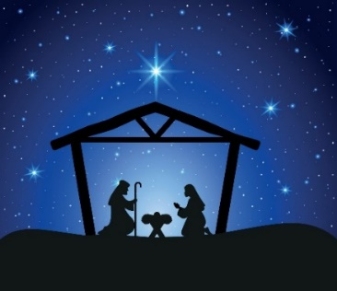

CANDLE NATIVITY
WITH CHRISTINGLE
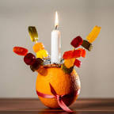
10.45am Sunday 10th December.

Do join us for an interactive fun-filled
morning for all the family
as we celebrate the birth of Jesus
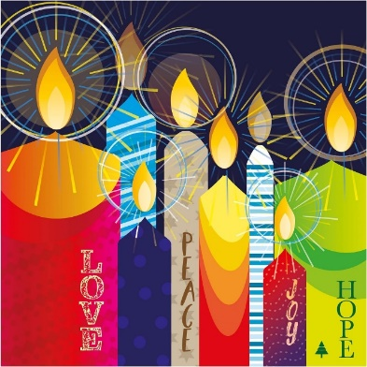
Help us to find the coloured candles around the church to build the nativity

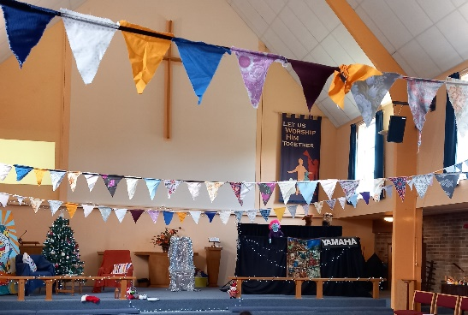
Welcome our special guests
‘the puppets’

Sparkly Chair!
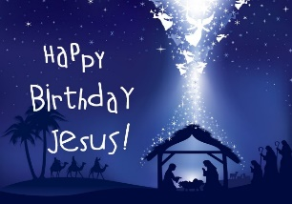

Sing old and new carols

Festive refreshments
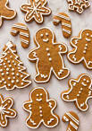
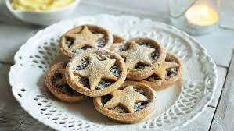

No charge, no need to book

